Is324

On mac:

## 1-Installing Git

Git is actually installed on MacOS, but we'll be reinstalling it so that we'll have the newest version:

1. go to <https://git-scm.com/downloads>
2. download the software for Mac
3. install Git choosing all of the default options

Once everything is installed, you should be able to run git on the command line. If it displays the usage information, then you're good to go!

If you run into any issues, please remember to take advantage of [Knowledge](https://knowledge.udacity.com/) and the community in your Student Hub.

**Configuring Mac's Terminal**

We're about to configure the Terminal to display helpful information when in a directory that's under version control. *This is an optional step!* You do not need to re-configure your terminal for Git to work. You can complete the entire course without reconfiguring it. However, reconfiguring the Terminal makes it significantly easier to use.

If you choose to configure your Terminal, here's what it should look like when you're finished.

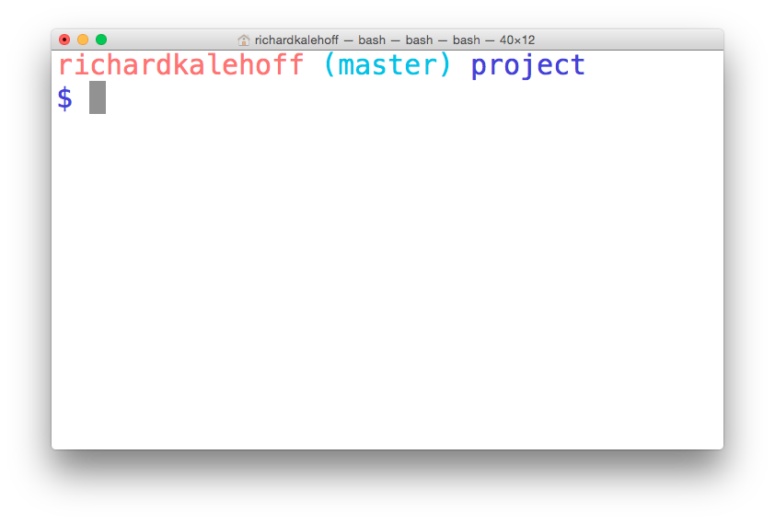

*The terminal application on MacOS. The terminal has been configured to display version control information.*

**Configuration Steps**

To configure the terminal, we'll perform the following steps:

1. download the zipped file from <https://www.dropbox.com/s/jdwc0po7lka6cat/KSU-IS324.zip?dl=0>
2. move the directory KSU-IS324 to your home directory and name it .KSU-IS324  (there's a dot at the front, now!)
3. move the bash_profile file to your home directory and name it .bash_profile (there's a dot at the front, now!)
   * if you *already* have a .bash_profile file in your home directory, transfer the content from the downloaded bash_profile to your existing .bash_profile

--------------------------------------------

**First Time Git Configuration**

Before you can start using Git, you need to configure it. Run each of the following lines on the command line to make sure everything is set up.

*# sets up Git with your name*

git config --global user.name "<Your-Full-Name>"

*# sets up Git with your email*

git config --global user.email "<your-email-address>"

*# makes sure that Git output is colored*

git config --global color.ui auto

*# displays the original state in a conflict*

git config --global merge.conflictstyle diff3

git config --list

**Git & Code Editor**

The last step of configuration is to get Git working with your code editor. Below are three of the most popular code editors. If you use a different editor, then do a quick search on Google for "associate X text editor with Git" (replace the X with the name of your code editor).

**Atom Editor Setup**

git config --global core.editor "atom --wait"

**Sublime Text Setup**

git config --global core.editor "'/Applications/Sublime Text 2.app/Contents/SharedSupport/bin/subl' -n -w"

**VSCode Setup**

git config --global core.editor "code --wait"

If you have any questions, post them on the forum.

On windows:

## Installing Git

To download Git:

1. go to <https://git-scm.com/downloads>
2. download the software for Windows
3. install Git choosing all of the default options

Once everything is installed, you should be able to run git on the command line. If it displays the usage information, then you're good to go!

If you run into any issues, please remember to take advantage of [Knowledge](https://knowledge.udacity.com/) and the community in your Study Group.

## Configuring the Command Prompt on Windows

We're about to configure the Command Prompt to display helpful information when in a directory that's under version control. This is an optional step! You do not need to re-configure your Command Prompt for Git to work. You can complete the entire course without reconfiguring it. However, reconfiguring the Command Prompt makes it significantly easier to use.

If you choose to configure your Command Prompt, here's what it should look like when you're finished.

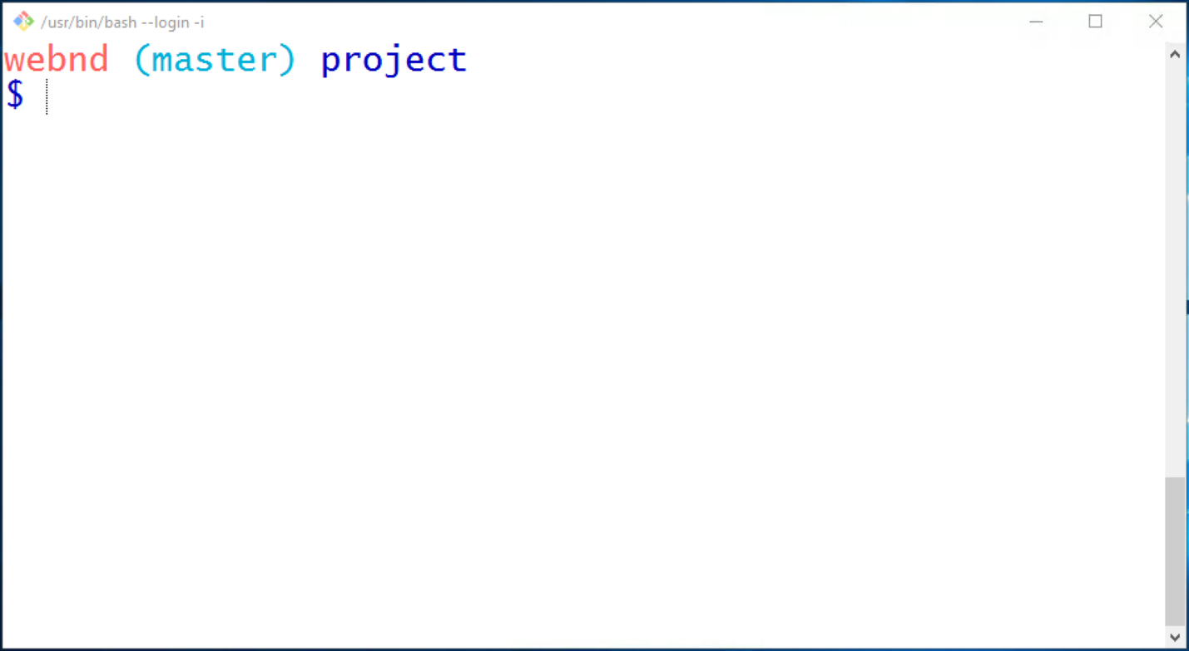

The Command Prompt application on Windows. The Command Prompt has been configured to display version control information.

## First Time Git Configuration

Before you can start using Git, you need to configure it. Run each of the following lines on the command line to make sure everything is set up.

*# sets up Git with your name*

git config --global user.name "<Your-Full-Name>"

*# sets up Git with your email*

git config --global user.email "<your-email-address>"

*# makes sure that Git output is colored*

git config --global color.ui auto

*# displays the original state in a conflict*

git config --global merge.conflictstyle diff3

git config --list

### Git & Code Editor

The last step of configuration is to get Git working with your code editor. Below are three of the most popular code editors. If you use a different editor, then do a quick search on Google for "associate X text editor with Git" (replace the X with the name of your code editor).

### Atom Editor Setup

git config --global core.editor "atom --wait"

### Sublime Text Setup

git config --global core.editor "'C:/Program Files/Sublime Text 2/sublime_text.exe' -n -w"

### VSCode Setup

git config --global core.editor "code --wait"